**11-5**

$$X_{1}=\frac{T_{1}-60}{20}{,X}_{2}=\frac{T_{2}-250}{50}{,X}_{3}=\frac{P_{1}-35}{15}$$

$$∆X_{1}=\frac{5}{20}=0.25$$

$$∆T_{1}=5$$

$$∆X_{1}=\frac{\overline{β_{1}}}{2λ}, or \frac{5}{2λ}=0.25, 2λ=20$$

$$∆X_{2}=\frac{\overline{β_{2}}}{2λ}=\frac{2.5}{20}=0.125$$

$$∆X_{3}=\frac{\overline{β_{3}}}{2λ}=\frac{3.5}{20}=0.175$$

|  |  |  |  |  |  |  |
| --- | --- | --- | --- | --- | --- | --- |
|  | coded | variables |  | natural | variables |  |
|  | $$X_{1}$$ | $$X_{2}$$ | $$X_{3}$$ | $$T_{1}$$ | $$T_{2}$$ | P |
| Origin | 0 | 0 | 0 | 60 | 250 | 35 |
| $$∆$$ | 0.25 | 0.125 | 0.175 | 5 | 6.25 | 2.625 |
| Origin+ $∆$ | 0.25 | 0.125 | 0.175 | 65 | 256.25 | 37.625 |
| Origin+5 $∆$ | 1.25 | 0.625 | 0.875 | 85 | 281.25 | 48.125 |

So, T1=85, T2=325, and P=60 is not on the path.

**11-6**

**(a).**

$$X_{1}=\frac{T-200}{100},X_{2}=\frac{C-20}{10}$$

$$∆T=100$$

$$∆X_{1}=\frac{100}{100}=1$$

$$∆X_{1}=\frac{\overline{β_{1}}}{2λ}=\frac{125}{2λ}=1, 2λ=125$$

$$∆X_{1}=\frac{\overline{β_{2}}}{2λ}=\frac{40}{125}=0.32$$

|  |  |  |  |  |
| --- | --- | --- | --- | --- |
|  | coded | variables | natural | variables |
|  | $$X_{1}$$ | $$X_{2}$$ | T | C |
| Origin | 0 | 0 | 200 | 20 |
| $$∆$$ | 1 | 0.32 | 100 | 3.2 |
| Origin+ $∆$ | 1 | 0.32 | 300 | 23.2 |
| Origin+5 $∆$ | 5 | 1.6 | 700 | 36 |

**(b).**

$$∆\overline{y}=∆X_{1}\overline{β_{1}}+∆X_{2}\overline{β_{2}}=1*125+0.32*40=137.8$$

$$\frac{2500-2000}{137.8}=3.63≈4$$

So, 4 steps would be required.

**11-9**

**Response: y**

**ANOVA for Response Surface Quadratic Model**

**Analysis of variance table [Partial sum of squares]**

**Sum of Mean F**

**Source Squares DF Square Value Prob > F**

Model 264.22 4 66.06 2.57 0.1194 not significant

A 13.11 1 13.11 0.51 0.4955

B 25.72 1 25.72 1.00 0.3467

$A^{2}$ 81.39 1 81.39 3.16 0.1132

AB 144.00 1 144.00 5.60 0.0455

Residual 205.78 8 25.72

*Lack of Fit* 190.98 4 47.74 12.90 0.0148 significant

*Pure Error* 14.80 4 3.70

Cor Total 470.00 12

The "Model F-value" of 2.57 implies the model is not significant relative to the noise.

There is a 11.94 % chance that a "Model F-value" this large could occur due to noise.

Std. Dev. 5.07 R-Squared 0.5622

Mean 45.00 Adj R-Squared 0.3433

C.V. 11.27 Pred R-Squared -0.5249

PRESS 716.73 Adeq Precision 4.955

**Coefficient Standard 95% CI 95% CI**

**Factor Estimate DF Error Low High VIF**

Intercept 42.91 1 1.83 38.69 47.14

A-Temperature 1.28 1 1.79 -2.85 5.42 1.00

B-Pressure -1.79 1 1.79 -5.93 2.34 1.00

${A }^{2}$ 3.39 1 1.91 -1.01 7.79 1.00

AB 6.00 1 2.54 0.15 11.85 1.00

**Final Equation in Terms of Coded Factors:**

Time =

+42.91

+1.28 * A

-1.79 * B

+3.39 * A2

+6.00 * A * B

**Final Equation in Terms of Actual Factors:**

Time =

+42.91304

+1.28033 * Temperature

-1.79289 * Pressure

+3.39130 * Temperature2

+6.00000 * Temperature * Pressure

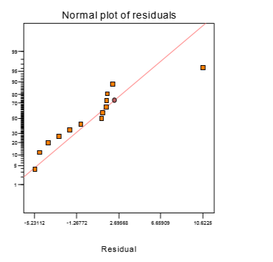

The residual plot shows an outlier which is standard order number 8

So remove this run, then analyze again.

**Response: y**

**ANOVA for Response Surface Quadratic Model**

**Analysis of variance table [Partial sum of squares]**

**Sum of Mean F**

**Source Squares DF Square Value Prob > F**

Model 407.34 4 101.84 30.13 0.0002 significant

A 13.11 1 13.11 3.88 0.0895

B 132.63 1 132.63 39.25 0.0004

$A^{2}$ 155.27 1 155.27 45.95 0.0003

AB 144.00 1 144.00 42.61 0.0003

Residual 23.66 7 3.38

*Lack of Fit* 8.86 3 2.95 0.8 0.5560 not significant

*Pure Error* 14.80 4 3.70

Cor Total 431.00 11

The "Model F-value" of 30.13 implies the model is not significant relative to the noise.

There is a 0.02 % chance that a "Model F-value" this large could occur due to noise.

Std. Dev. 1.84 R-Squared 0.9451

Mean 44.50 Adj R-Squared 0.9138

C.V. 4.13 Pred R-Squared 0.8129

PRESS 80.66 Adeq Precision 18.243

**Coefficient Standard 95% CI 95% CI**

**Factor Estimate DF Error Low High VIF**

Intercept 40.68 1 0.73 38.95 42.40

A-Temperature 1.28 1 0.65 -0.26 2.82 1.00

B-Pressure -4.82 1 0.77 -6.64 -3.00 1.02

${A }^{2}$ 4.88 1 0.72 3.18 6.59 1.02

AB 6.00 1 0.92 3.83 8.17 1.00

**Final Equation in Terms of Coded Factors:**

Time =

+40.68

+1.28 * A

-4.82 * B

+4.88 * A2

+6.00 * A * B

**Final Equation in Terms of Actual Factors:**

Time =

+40.67673

+1.28033 * Temperature

-4.82374 * Pressure

+4.88218 * Temperature2

+6.00000 * Temperature * Pressure

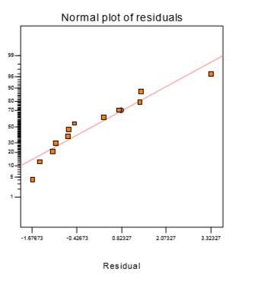

**(a).**

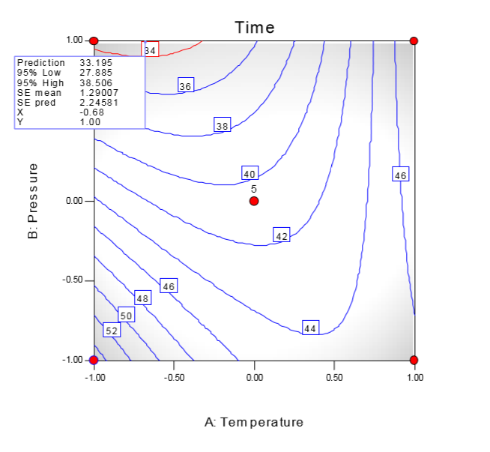

**(b).**

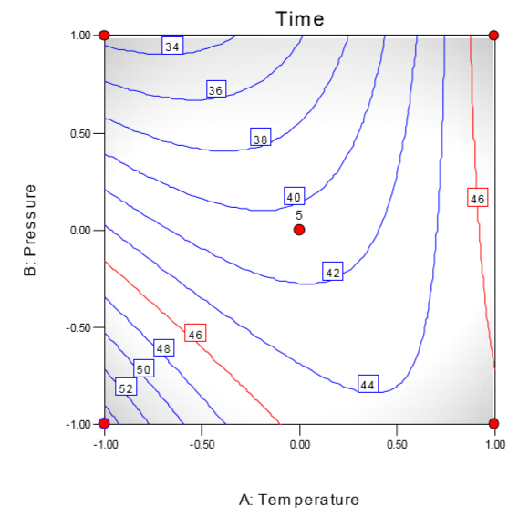

**11-12**

**Response: y**

**ANOVA for Response Surface Quadratic Model**

**Analysis of variance table [Partial sum of squares]**

**Sum of Mean F**

**Source Squares DF Square Value Prob > F**

Model 2555.73 9 283.97 12.76 0.0002 significant

A 14.44 1 14.44 0.65 0.4391

B 222.96 1 222.96 10.02 0.0101

C 525.64 1 525.64 23.63 0.0007

A2 48.47 1 48.47 2.18 0.1707

B2 124.48 1 124.48 5.60 0.0396

C2 388.59 1 388.59 17.47 0.0019

AB 36.13 1 36.13 1.62 0.2314

AC 1035.13 1 1035.13 46.53 < 0.0001

BC 120.12 1 120.12 5.40 0.0425

Residual 222.47 10 22.25

Lack of Fit 56.47 5 11.29 0.34 0.8692 not significant

Pure Error 166.00 5 33.20

Cor Total 2 87.28 19

The Model F-value of 12.76 implies the model is significant.

There is only a 0.02% chance that a "Model F-Value" this large could occur due to noise.

Std. Dev. 4.72 R-Squared 0.9199

Mean 78.30 Adj R-Squared 0.8479

C.V. 6.02 Pred R-Squared 0.7566

PRESS 676.22 Adeq Precision 14.239

**Coefficient Standard 95% CI 95% CI**

**Factor Estimate DF Error Low High VIF**

Intercept 81.09 1 1.92 76.81 85.38

A-Time 1.03 1 1.28 -1.82 3.87 1.00

B-Temperature 4.04 1 1.28 1.20 6.88 1.00

C-Catalyst 6.20 1 1.28 3.36 9.05 1.00

A2 -1.83 1 1.24 -4.60 0.93 1.02

B2 2.94 1 1.24 0.17 5.71 1.02

C2 -5.19 1 1.24 -7.96 -2.42 1.02

AB 2.13 1 1.67 -1.59 5.84 1.00

AC 11.38 1 1.67 7.66 15.09 1.00

BC -3.87 1 1.67 -7.59 -0.16 1.00

Final Equation in Terms of Coded Factors:

Conversion =

+81.09

+1.03 * A

+4.04 * B

+6.20 * C

-1.83 * A2

+2.94 * B2

-5.19 * C2

+2.13 * A * B

+11.38 * A * C

-3.87 * B * C

Final Equation in Terms of Actual Factors:

Conversion =

+81.09128

+1.02845 * Time

+4.04057 * Temperature

+6.20396 * Catalyst -

1.83398 * Time2

+2.93899 * Temperature2

-5.19274 * Catalyst2

+2.12500 * Time * Temperature

+11.37500 * Time * Catalyst

-3.87500 * Temperature * Catalyst

**Response: y**

**ANOVA for Response Surface Quadratic Model**

**Analysis of variance table [Partial sum of squares]**

**Sum of Mean F**

**Source Squares DF Square Value Prob > F**

Model 256.20 9 28.47 9.16 0.0009 significant

A 175.35 1 175.35 56.42 < 0.0001

B 0.89 1 0.89 0.28 0.6052

C 67.91 1 67.91 21.85 0.0009

A2 10.05 1 10.05 3.23 0.1024

B2 0.081 1 0.081 0.026 0.8753

C2 0.047 1 0.047 0.015 0.9046

AB 1.20 1 1.20 0.39 0.5480

AC 0.011 1 0.011 3.620E-003 0.9532

BC 0.78 1 0.78 0.25 0.6270

Residual 31.08 1 0 3.11

Lack of Fit 27.43 5 5.49 7.51 0.0226 significant

Pure Error 3.65 5 0.73

Cor Total 287.28 19

The Model F-value of 9.16 implies the model is significant.

There is only a 0.09% chance that a "Model F-Value" this large could occur due to noise.

Std. Dev. 1.76 R-Squared 0.8918

Mean 60.51 Adj R-Squared 0.7945

C.V. 2.91 Pred R-Squared 0.2536

PRESS 214.43 Adeq Precision 10.911

**Coefficient Standard 95% CI 95% CI**

**Factor Estimate DF Error Low High VIF**

Intercept 59.85 1 0.72 58.25 61.45

A-Time 3.58 1 0.48 2.52 4.65 1.00

B-Temperature 0.25 1 0.48 -0.81 1.32 1.00

C-Catalyst 2.23 1 0.48 1.17 3.29 1.00

A2 0.83 1 0.46 -0.20 1.87 1.02

B2 0.075 1 0.46 -0.96 1.11 1.02

C2 0.057 1 0.46 -0.98 1.09 1.02

AB -0.39 1 0.62 -1.78 1.00 1.00

AC -0.038 1 0.62 -1.43 1.35 1.00

BC 0.31 1 0.62 -1.08 1.70 1.00

Final Equation in Terms of Coded Factors:

Conversion =

+59.85

+3.58 * A

+0.25 * B

+2.23 * C

+0.83 * A2

+0.075 * B2

+0.057 * C2

-0.39 * A * B

-0.038 * A * C

+0.31 * B * C

Final Equation in Terms of Actual Factors:

Conversion =

+59.84984

+3.58327 * Time

+0.25462 * Temperature

+2.22997 * Catalyst

+0.83491 * Time2

+0.074772 *Temperature2

+0.057094 * Catalyst2

-0.38750 * Time * Temperature

-0.037500 * Time * Catalyst

+0.31250 * Temperature * Catalys

Little terms are insignificant, so we modify the model:

**Response: y**

**ANOVA for Response Surface Quadratic Model**

**Analysis of variance table [Partial sum of squares]**

**Sum of Mean F**

**Source Squares DF Square Value Prob > F**

Model 253.20 3 84.40 39.63 < 0.0001 significant

A 175.35 1 175.35 82.34 < 0.0001

C 67.91 1 67.91 31.89 < 0.0001

A2 9.94 1 9.94 4.67 0.0463

Residual 34.07 16 2.13

Lack of Fit 30.42 11 2.77 3.78 0.0766 not significant

Pure Error 3.65 5 0.73

Cor Total 287.28 19

The Model F-value of 39.63 implies the model is significant.

There is only a 0.01% chance that a "Model F-Value" this large could occur due to noise

Std. Dev. 1.46 R-Squared 0.8814

Mean 60.51 Adj R-Squared 0.8591

C.V. 2.41 Pred R-Squared 0.6302

PRESS 106.24 Adeq Precision 20.447

**Coefficient Standard 95% CI 95% CI**

**Factor Estimate DF Error Low High VIF**

Intercept 59.95 1 0.42 59.06 60.83

A-Time 3.58 1 0.39 2.75 4.42 1.00

C-Catalyst 2.23 1 0.39 1.39 3.07 1.00

A2 0.82 1 0.38 0.015 1.63 1.00

Final Equation in Terms of Coded Factors:

Activity =

+59.95

+3.58 * A

+2.23 * C

+0.82 * A2

Final Equation in Terms of Actual Factors:

Activity =

+59.94802

+3.58327 * Time

+2.22997 * Catalyst

+0.82300 * Time2

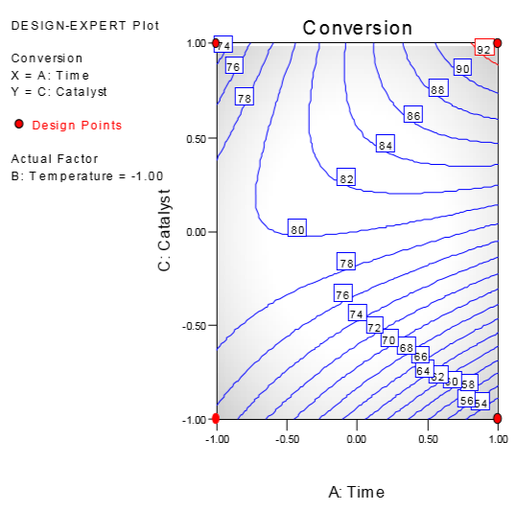

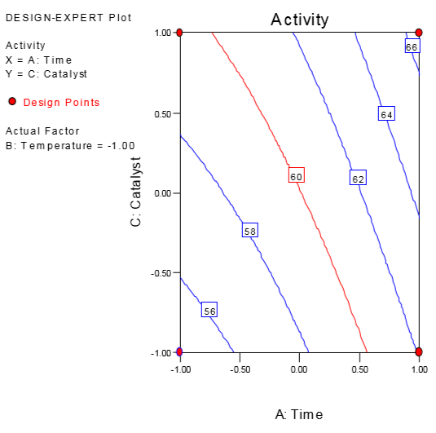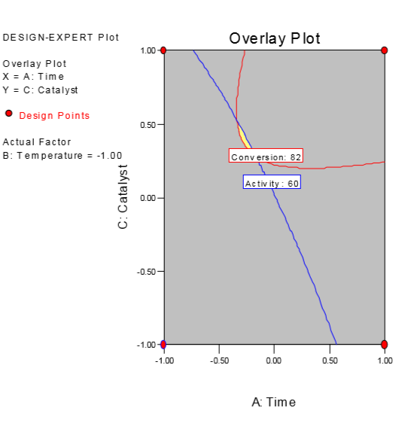

**11-18**

$$\sum_{u=1}^{k}{x_{2u}^{2}}=13.334, n=20$$

For block 1 and 2:

$$\sum_{m}{x_{2m}^{2}}=4, n_{m}=6$$

$$\frac{\sum_{m}{x_{2m}^{2}}}{\sum_{u=1}^{k}{x_{2u}^{2}}}=n_{m}=6$$

$$\frac{4}{13.334}=\frac{6}{20}$$

0.3=0.3

For block3:

$$\sum_{m}{x_{2m}^{2}}=5.334, n_{m}=8$$

$$\frac{\sum_{m}{x_{2m}^{2}}}{\sum_{u=1}^{k}{x_{2u}^{2}}}=\frac{n_{m}}{n}$$

$$\frac{5.334}{13.334}=\frac{8}{20}$$

0.4=0.4

**11-19**

$$\frac{\sum_{m}{x_{im}^{2}}block1}{\sum_{m}{x_{im}^{2}}blcok2}=\frac{n_{f}+n_{c1}}{2k+n_{c2}}$$

$$\frac{n_{f}}{2α^{2}}=\frac{n_{f}+n_{c1}}{2k+n_{c2}}$$

$$α={\left[\left.\frac{n_{f}\left(2k+n_{c2}\right)}{2\left(n_{f}+n_{c1}\right)}\right]\right.}^{\frac{1}{2}}$$

$$n_{f}={\left[\left.\frac{n_{f}\left(2k+n_{c2}\right)}{2\left(n_{f}+n_{c1}\right)}\right]\right.}^{2}$$

It is impossible to get rotatable central composite designs.

**11-31**

**(a).**

A simplex centroid design

**(b).**

**Response: y**

**ANOVA for Response Surface Quadratic Model**

**Analysis of variance table [Partial sum of squares]**

**Sum of Mean F**

**Source Squares DF Square Value Prob > F**

Model 4.22 5 0.84 3.90 0.0435 significant Linear Mixture 3.92 2 1.96 9.06 0.0088

AB 0.15 1 0.15 0.69 0.4289

AC 0.081 1 0.081 0.38 0.5569

BC 0.077 1 0.077 0.36 0.5664

Residual 1.73 8 0.22

Lack of Fit 0.50 4 0.12 0.40 0.8003 not significant Pure Error 1.24 4 0.31

Cor Total 5.95 13

The Model F-value of 3.90 implies the model is significant.

There is only a 4.35% chance that a "Model F-Value" this large could occur due to noise.

Std. Dev. 0.47 R-Squared 0.7091

Mean 24.16 Adj R-Squared 0.5274

C.V. 1.93 Pred R-Squared 0.1144

PRESS 5.27 Adeq Precision 5.674

**Coefficient Standard 95% CI 95% CI**

**Factor Estimate DF Error Low High VIF**

A-x1 24.74 1 0.32 24.00 25.49

B-x2 24.31 1 0.32 23.57 25.05

C-x3 23.18 1 0.32 22.43 23.92

AB 1.51 1 1.82 -2.68 5.70

AC 1.11 1 1.82 -3.08 5.30

BC -1.09 1 1.82 -5.28 3.10

Final Equation in Terms of Pseudo Components:

y =

+24.74 * A

+24.31 * B

+23.18 * C

+1.51 * A * B

+1.11 * A * C

-1.09 * B * C

Final Equation in Terms of Real Components:

y =

+24.74432 * x1

+24.31098 * x2

+23.17765 * x3

+1.51364 * x1 * x2

+1.11364 * x1 * x3

-1.08636 * x2 * x3

The quadratic terms appear to be insignificant. The analysis below is for the linear mixture model:

**Response: y**

**ANOVA for Response Surface Quadratic Model**

**Analysis of variance table [Partial sum of squares]**

**Sum of Mean F**

**Source Squares DF Square Value Prob > F**

Model 3.92 2 1.96 10.64 0.0027 significant Linear Mixture 3.92 2 1.96 10.64 0.0027

Residual 2.03 11 0.18

Lack of Fit 0.79 7 0.11 0.37 0.8825 not significant Pure Error 1.24 4 0.31

Cor Total 5.95 13

The Model F-value of 10.64 implies the model is significant.

There is only a 0.27% chance that a "Model F-Value" this large could occur due to noise.

Std. Dev. 0.43 R-Squared 0.6591

Mean 24.16 Adj R-Squared 0.5972

C.V. 1.78 Pred R-Squared 0.3926

PRESS 3.62 Adeq Precision 8.751

**Coefficient Standard 95% CI 95% CI**

**Component Estimate DF Error Low High**

A-x1 24.93 1 0.25 24.38 25.48

B-x2 24.35 1 0.25 23.80 24.90

C-x3 23.19 1 0.25 22.64 23.74

**Adjusted Adjusted Approx t for H0**

**Component Effect DF Std Error Effect=0 Prob > |t|**

A-x1 1.16 1 0.33 3.49 0.0051

B-x2 0.29 1 0.33 0.87 0.4021

C-x3 -1.45 1 0.33 -4.36 0.0011

Final Equation in Terms of Pseudo Components:

y =

+24.93 * A

+24.35 * B

+23.19 * C

Final Equation in Terms of Real Components:

y =

+24.93048 * x1

+24.35048 * x2

+23.19048 * x3

**(c)**.

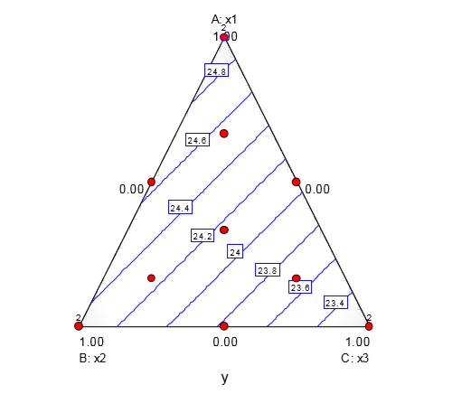

when blend is x1 = 1, x2 = 0, x3 = 0. The result would be maximize.